**Weather Project**

**Q1. Create a table “ STATION “ to store information about weather**

**observation stations:**

**Query-**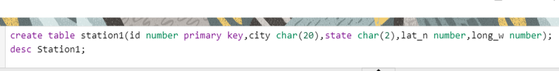

**Ans.-**

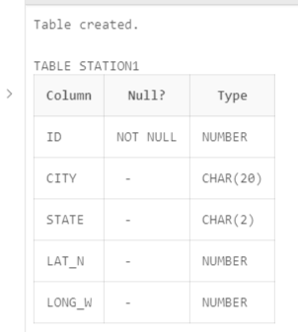

Q2- **Insert the following records into the table:**

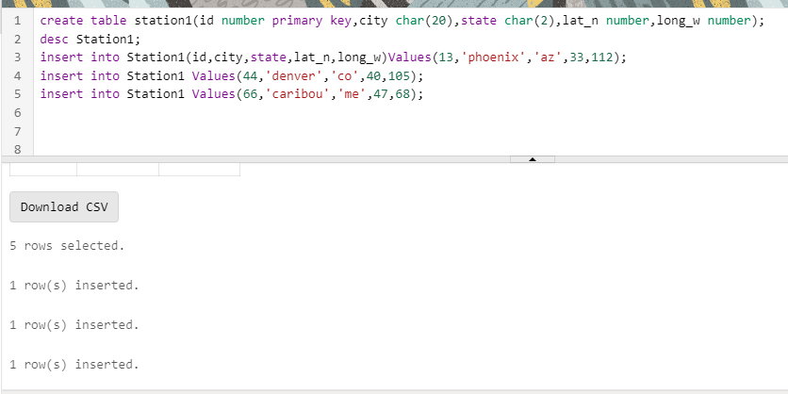

Q3) Execute a query to look at table STATION in undefined order.

Query Ans-

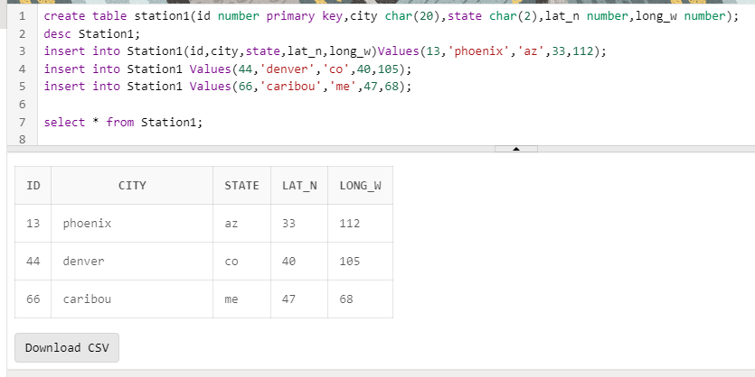

Q4) Execute a query to select Northern stations

(Northern latitude > 39.7).

Query Ans:-

D:\haircare\q4query.png

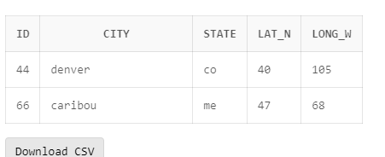

5. Create another table, ‘STATS’, to store normalized temperature and

precipitation data:

Query

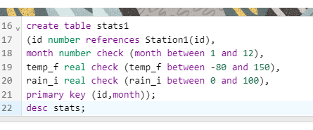

Ans:-

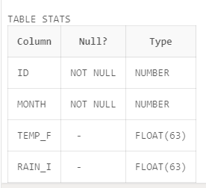

Q6) Populate the table STATS with some statistics for January and July:

Query- select * from stats;

Ans:-

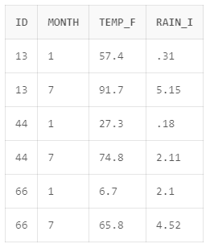

Q7) Execute a query to display temperature stats (from the STATS table)

for each city (from the STATION table).

Query:-select * from Station1,stats where Station1.id=stats.id;

Ans:-

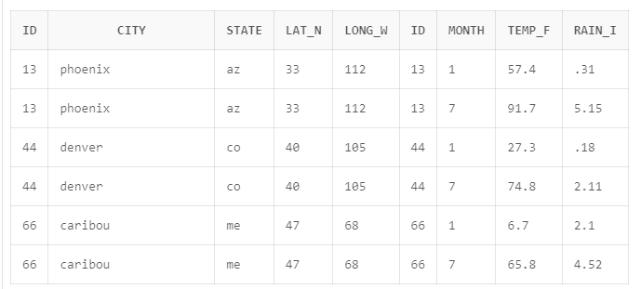

Q8) Execute a query to look at the table STATS, ordered by month and

greatest rainfall, with columns rearranged. It should also show the

corresponding cities.

Query- select city, month, station.id, rain_i, temp_f

from stats

right join station on stats.id = station.id

order by month, rain_i desc;

Ans:-

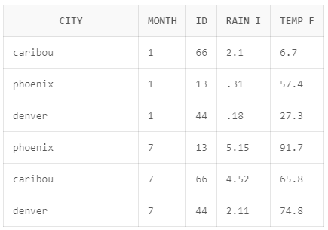

Q9) Execute a query to look at temperatures for July from table STATS,

lowest temperatures first, picking up city name and latitude.

query:- select temp_f, city, lat_n

from stats,

station

where month = 7 and stats.id = station.id

order by temp_f;

Ans:-

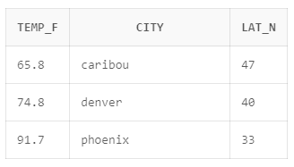

Q10) Execute a query to show MAX and MIN temperatures as well as

average rainfall for each city.

query:-

select id, max(temp_f), min(temp_f), avg(rain_i), id

from stats

group by id;

Ans:-

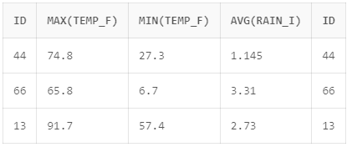

Q11)Execute a query to display each city‟s monthly temperature in Celcius

and rainfall in Centimeter.

QUERY:

select sta.city,s.month,

round(((s.temp_f-32) * 5/9), 2) as temperature_celcius,

round((s.rain_i * 2.54), 2) as rainfall_centimeter from stats s

join station st on s.id=sta.id;

Ans:-

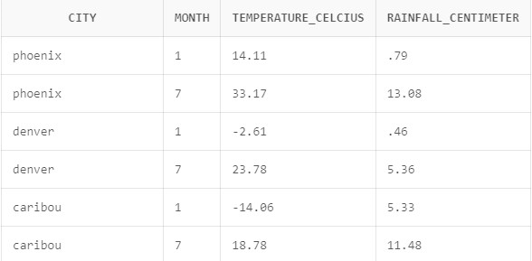

Q12) Update all rows of table STATS to compensate for faulty rain

gauges known to read 0.01 inches low.

Query:-update stats set rain_i=rain_i+0.01;

Ans:-

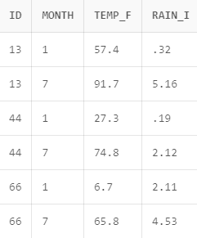

Q13)Update Denver’s July temperature reading as 74.9.

Query:- update stats set tem_f=74.9 where id=44 and month=7;

Select*from stats;

Ans:-

